
Swift Property Solutions, Inc.
Investing in our communities
Swift Property Solutions, Inc. is a premier real estate solutions company located in Las Vegas, Nevada. The company specializes in solving complicated real estate matters for people throughout Clark County.
We will buy your house fast!
Real Estate Specialties
Sell your Property without Realtor Commissions
Little or No Equity Sales
Foreclosure Avoidance
Title Issues
Relocation Assistance
Vacant Properties
Bankruptcy
Overleveraged Properties
Judgments or Outside Liens
Credit Repair
First Time Homebuyer Programs
Call us today and we can discuss your options!
1.844.614.1777

Swift Property Solutions is proud to provide real estate services in the following areas:
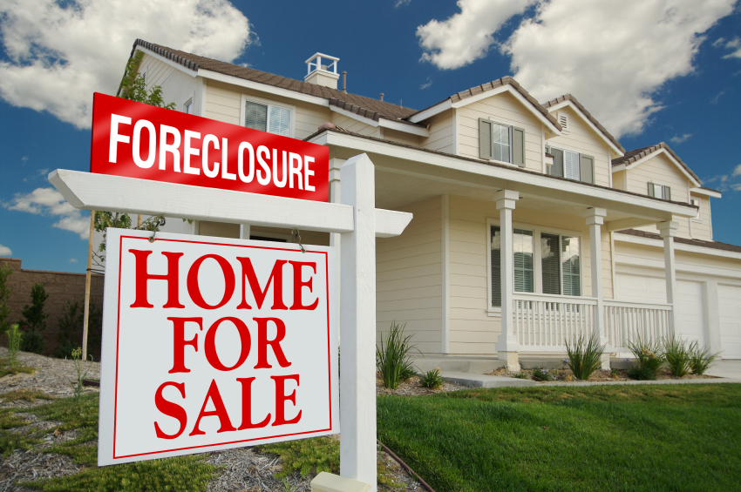
• Residential Redevelopment
• Short Sales/Loss Mitigation
• Real Estate Investment
Since its inception, Swift Property Solutions has helped homeowners find solutions to their complicated real estate problems. If you are looking to sell your house quickly, or if you have found yourself in a real estate dilemma and you are simply looking for answers, we can help. Every year there are hundreds of thousands of people who get hit with one of life’s unexpected curve balls, sometimes forcing them to sell their house. Most people are not aware of their options beyond listing a house with a Realtor, or trying to sell their house on their own and just hoping for the best. We work with each homeowner individually and explore all possible options. Our goal is to put power back in your hands.
Our Mission
Swift Property Solutions is devoted to delivering the right real estate solution to the right situation in a timely fashion. Our goal is to use our knowledge and expertise to improve the communities we serve and be recognized as a valued asset and partner.
WHY WORK WITH us?
When we work directly with a home seller, what we provide can not only make for a smooth transaction, but it can also add up to thousands upon thousands of dollars in savings as compared to selling a home through traditional means. With the ability to directly purchase homes and make cash offers, we can create fast and hassle-free transactions.
There are many creative ways to help you out of any situation. We pride ourselves on our reputation for working one-on-one with each customer to handle each individual situation; and it’s our goal to make each client feel like we achieved a WIN-WIN scenario.
Most homeowners have no idea what options are available to them beyond listing a house with a Realtor or trying to sell the house on their own and just hoping for the best. We provide a unique alternative to listing their house on their own or with a Realtor. Your Realtor gets paid a commission for his or her services which is a percentage of the home’s selling price. In most cases, you may also be encouraged to fix up your home and yard to attract more potential buyers – and sometimes it can involve hiring expensive contractors.
how do we compare to a traditional buyer?

Traditional BuyerSwift Property SolutionsMethod of PaymentBank FinancingCASHRepairs1-8% of Homes ValueNone (Sold AS-IS)Closing Timeframe45+ Days10-14 DaysCommissions6% of Sale PriceNoneSeller Paid Closing Costs1-6% of the Purchase PriceZeroAppraisalMandatoryNoneLength of Time on Market93 Days on the Market
(Las Vegas Average)0 Days

programs we offer
In many instances, it may be in your best interest to sell. If you are struggling to make the mortgage payment each month, you may need want to find a more affordable situation. Likewise, do not risk losing valuable equity to a pending foreclosure by not taking action. We can purchase your home directly from you and there are no hefty realtor commissions you will have to pay. We can also close very quickly or on your timeline, whatever you prefer. Call us today and we can make you an offer in less than 24 hours! We can be reached at 1.844.614.1777.
Cash Purchase Program
Utilizing cash funding from our national network of investors allows us to circumvent many of the nuances of a traditional real estate closing. We can purchase your home directly from you, and you won’t have to pay any hefty Realtor commissions. In addition to our funding source, we will be buying the home absolutely AS IS – meaning, we would never ask you to make a single repair on the home. Furthermore, Swift Property Solutions fully understands the importance of timing. You may be in a situation where you need to close quickly or, you may need a few months to transition your life. Either way, we can facilitate a fast and easy closing in 10 days or less - or as long as you need. We are here to work with you.

Credit Repair Programs
Whether you are looking to repair your credit from an unfortunate financial event or improve your credit score in order to purchase another home in the future, our network of credit repair specialists can produce results quickly. We can provide educational materials, step-by-step instruction, and professional credit coaching throughout the course of a year to help you get right back on track.
Homeowner Relocation Programs
We realize the challenges homeowners face when selling their property. This is why Swift Property Solutions created the Homeowner Relocation Program. We will work hand in hand with you to locate another home or an apartment depending on your needs. We can also arrange for movers to assist, if this is something you desire. We know selling a home can be stressful, and we believe in going the extra mile for our customers.
Renovation Projects

Occasionally, we sell houses that are not included in our completed renovation portfolio. When selling these properties in need of repair, it’s very important for the buyer to have specialized knowledge to identify any possible renovation costs associated with improving the property. When working with our company, you can be rest assured that we’re very qualified and experienced in accurately estimating repairs and consulting with buyers on the renovation process.
Our risks
There’s no such thing as a perfect house -- every home, even newly constructed ones, will potentially have some issue or another. Our company builds value by rehabilitating properties in need of repairs - whether light cosmetic repairs, or significant repairs.
In many cases, we buy houses that have fire damage, termites, mold, foundation problems, roof problems or need of other major repairs. Houses with these conditions scare most buyers, and most real estate agents don’t like listing them because they know such houses are hard to sell. We actually enjoy talking to sellers with these types of houses, because we can see the house’s potential value after all the repairs are made; and breathe new life back into them by renovating and improving the condition of the house.
Here are just a few risks involved when we purchase properties:
- Previously unknown property conditions, or environmental hazards, such as toxic-mold, or others
- Expensive repair conditions may not have been apparent at, or became worse since the time of purchase
- Costly repairs not previously estimated for could offset the profit margin, such as HVAC, plumbing, foundation, etc.
- Work permit complications, local restrictions, or codes and other legal problems that can arise
- Unexpectedly longer times in holding a property for repair, or marketing time extended, causing profits to be exhausted
- Ever changing market conditions, including lending requirements and availability of applicable mortgages for buyers
frequently Asked questions
How does the process work to sell my house?
Once we have some basic information on your property, a member of our team will contact you shortly with a cash offer (usually within 24 hours). In some situations, we will need to gather additional information about the condition of the home. Once complete, we will discuss all the details with you and make an offer the same day. If you accept, we will handle everything else, navigating the closing process from start to finish.
What sort of houses do you buy?
We buy houses in any condition, in any area, in any price range, in any situation! We will buy your house as-is - you don’t need to do any repairs! We love to revitalize communities customize properties from the ground up so condition does not matter to us.
What do you mean by “any condition, area, price range or situation”?
Whether your house is in foreclosure, over-leveraged, condemned, has liens or health department violations, not maintained, fire damaged, or about to fall down - we can buy it!
What will your service cost me?
Nothing! We do not charge you any fees to discuss your situation, make you an offer or to buy your home.
Is my information kept confidential?
Absolutely 100%! Your privacy is of the utmost importance to us. Any information you provide is completely confidential! If you want to deal with a reliable, reputable company who will treat you with professionalism, understanding, and respect – you have come to the right place!
If I know of another property your company may want to buy, do you pay a referral fee?
Yes! Referrals are our number one means of purchasing property. Maybe there is a vacant house on your street or you know someone who needs and wants to sell their home, please refer them to us! Better yet, provide us their information and we will do all the research and make an offer. Contact us directly to discuss the terms.

Are you still able to help if I am behind on my payments, in foreclosure or bankruptcy?
Yes! Swift Property Solutions is a professional real estate solutions company with experience in solving these difficult situations. We are connected with some of the best attorney’s in the business that are very well versed in foreclosures, bankruptcy, and short sales. We are happy to connect you to any one of them.

